**Setting up Java**

(Note: *The setup and installation steps given here are for Windows 10 operating systems*)

**Step 1**: Download OpenJDK 11

Go to site: <https://jdk.java.net/java-se-ri/11>

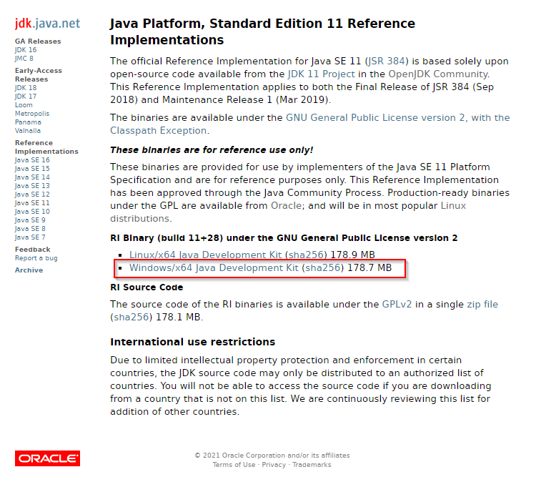

We get the zip file: **openjdk-11+28_windows-x64_bin.zip**

**Step 2**: Extract the downloaded zip file

Extract the **openjdk-11+28_windows-x64_bin.zip** file to the folder **jdk-11**

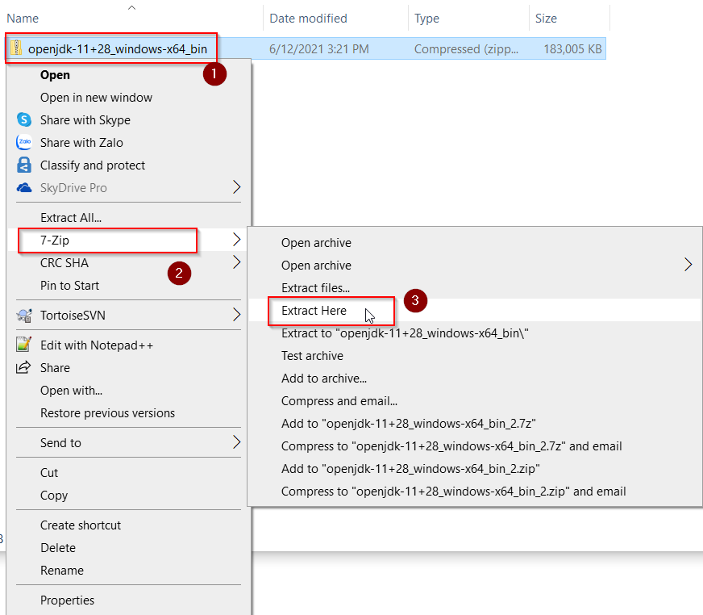

We get the “**jdk-11**” folder

**Step 3**: Create folder C:\java\openjdk

**Step 4**: Copy the extracted folder “**jdk-11**” to the folder C:\java\openjdk

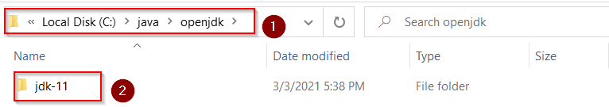

**Step 5**: Setting up environment variables

1. Navigate to **Start Menu | Settings | System | About | System info | Advanced system settings**.

2. A **System Properties** window will appear; in this window, select the **Advanced** tab and click on the **Environment Variables** button to open the **Environment Variables** window.

3. Now, click on the **New** button in the System variables panel and enter ***JAVA_HOME*** as the variable name and enter the installed JDK directory path as the variable value; in our case, this would be **C:\java\openjdk\jdk-11**. Like picture below

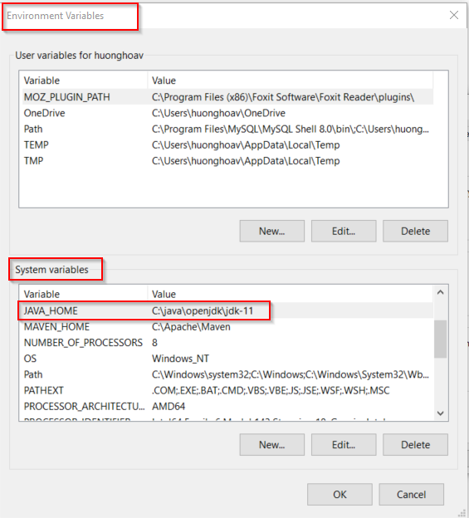

4. Now, in the same **System variables** panel, *double-click* on the **path** variable entry; an **Edit System Variable** window will appear. Like picture below

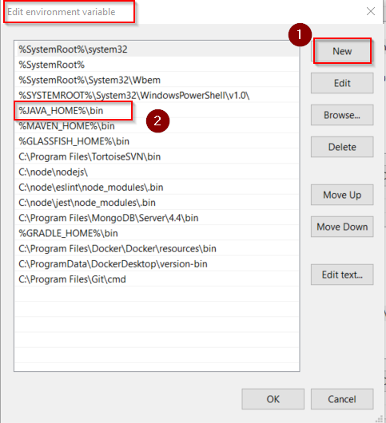

5. Edit Variable value of Path by clicking the new button and enter the following text **%JAVA_HOME%\bin** as the value.

6. Now click on the **OK** button.

**Step 6**: Verify JDK installation

Open CMD window and type: java –version

